Lightning component Implementation Details

Problem Statement: Create a lightning component to display the customer’s product information on the case detail page.

# Components Involved:

*Custom Object*: Product Information (**API Name** N26_ProductInformation__c)

- This object has been created to store the details of the products .To add/update products we would have to create new/update records

*Custom Fields*:

|  |  |  |  |
| --- | --- | --- | --- |
| Name | API Name | Data Type | Additional Information |
| Product | **Product__c** | **Picklist** | This field will include the product values. In our implementation we have added the below three values:   * Standard. * Metal * Black |
| Country Code | **Country_Code__c** | **Picklist** | We have created a global picklist which has been used for this field and “Home Country” field in Contact.  A Value can be added/removed from the global picklist and that would be reflected in both the fields |
| Type | **Type__c** | **Picklist** | We can add more values to the picklist like storage,license etc |
| Value | **Value__c** | **Text** | This is a text field to store the value of the corresponding product for a particular type and country |

Standard Object: Contact

## Custom Fields:

|  |  |  |  |
| --- | --- | --- | --- |
| Name | API Name | Data Type | Additional Information |
| Product Information | Product__c | Lookup(Product Information) | Lookup to Product Information Object.  This field has a lookup filter that would filter the records based on Home Country  **Note :This implementation is based on the assumption that a customer will have only one product associated with it** |
| Home Country | Home_Country__c | Picklist | We have created a global picklist which has been used for this field and “Home Country” field in Contact.  A Value can be added/removed from the global picklist and that would be reflected in both the fields |

*Global Picklist***:**

**Home_Country** (global picklist) is used in two custom fields Country_Code__c and Home_Country__c. We can add/remove values from the global picklist and the updated set of values would be reflected in the custom fields.

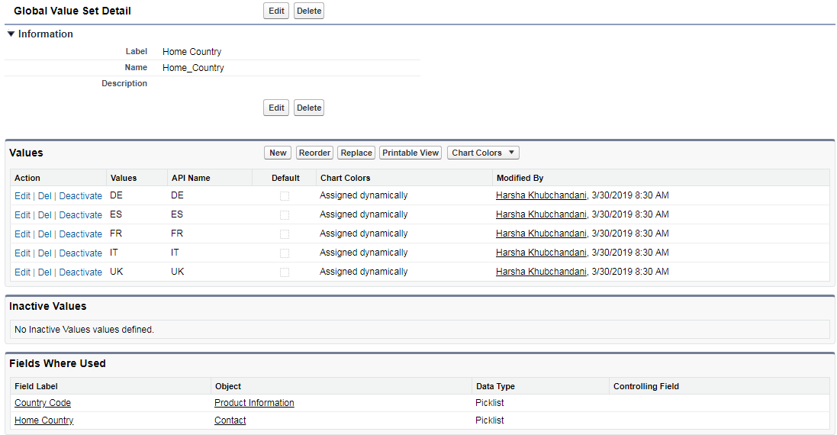

## *Lightning Component:* N26_CustomerProductInformation

This component has been added as a tab to the case record page. Below is the output

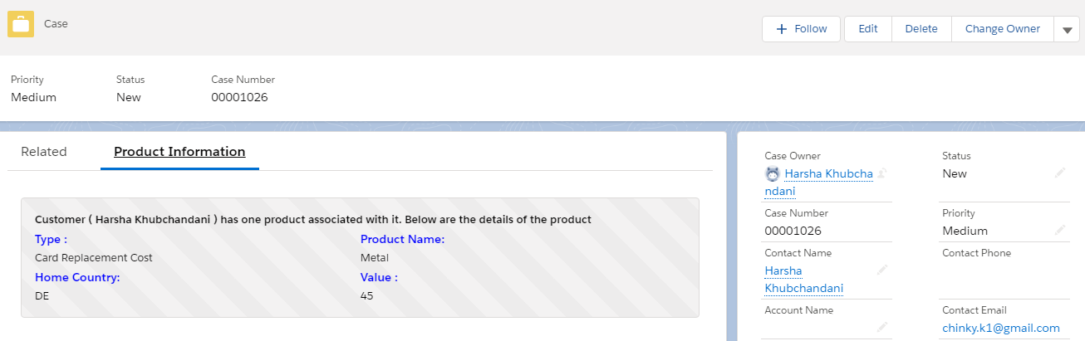

Below is the output when there is no product associated with the customer.

